13.2 practice

Graph the function (1-2): Write the function (3-4)

1.  2.  3. 4.

*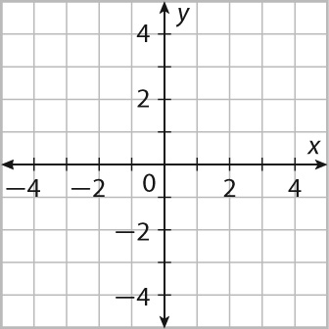* 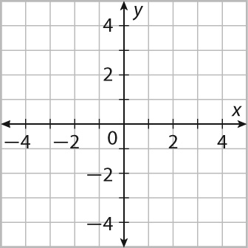 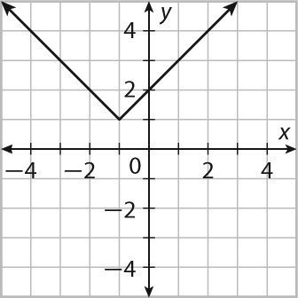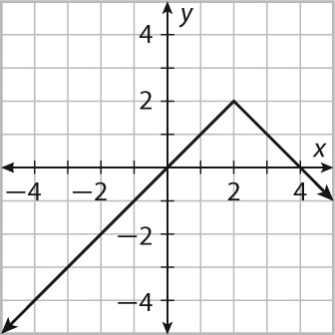

Graph the function (1-2): Write the function (3-4)

1.  2.  3. 4.

**  

Graph the function (1-2): Write the function (3-4)

1.  2.  3. 4.

**  