Algebra II Trig Test # 3 Review
Graph The following
- $y=4cos2\left(x+\frac{π}{6}\right)-2$
- $y=2cos\left(\frac{1}{2}x-2π\right)+3$
- $y=-3cos\left(3x+\frac{π}{6}\right)$
- $y=sin\left(4x-π/2\right)+3$
- $y=4sin\left(x-π\right)-1$
- $y=-5sin\left(x+\frac{π}{12}\right)$
Write the equations of the following graphs
8. Cosine:
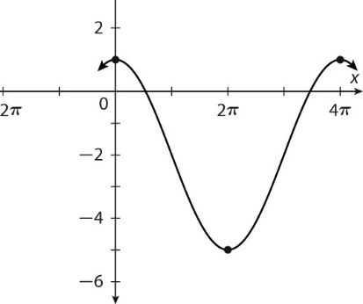
9. Sine:
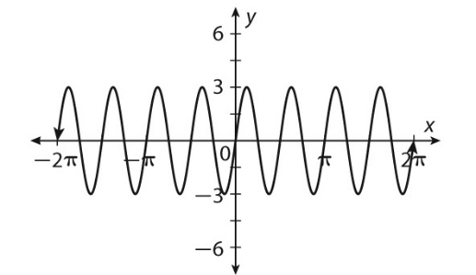
10. Sine: Write an equation for positive a and negative a
