- State the vertex, axis of symmetry, and the maximum or minimum values of the following functions (the first one is done for you):
  - $f\left(x\right)=x^{2}-3$
Vertex: (0, -3)
Axis of symmetry: x= 0
Minimum value: y = -3 (min because graph opens up)

  - $f\left(x\right)=-4{\left(x+5\right)}^{2}-2$

  - $f\left(x\right)={6\left(x-1\right)}^{2}$

- Describe the transformations of the graphs compared to $f\left(x\right)=x^{2}$. (the first one is done for you)
  - $f\left(x\right)=-\frac{1}{3}({x-4)}^{2}-3$
Reflection across the x axis (opens down)
Vertical compression of 1/3
Shift right 4, shift down 3

  - $f\left(x\right)=-{4\left(x+1\right)}^{2}$

  - $f\left(x\right)={\frac{1}{2}\left(x+4\right)}^{2}+4$

- Graph the following Functions. State the domain and range
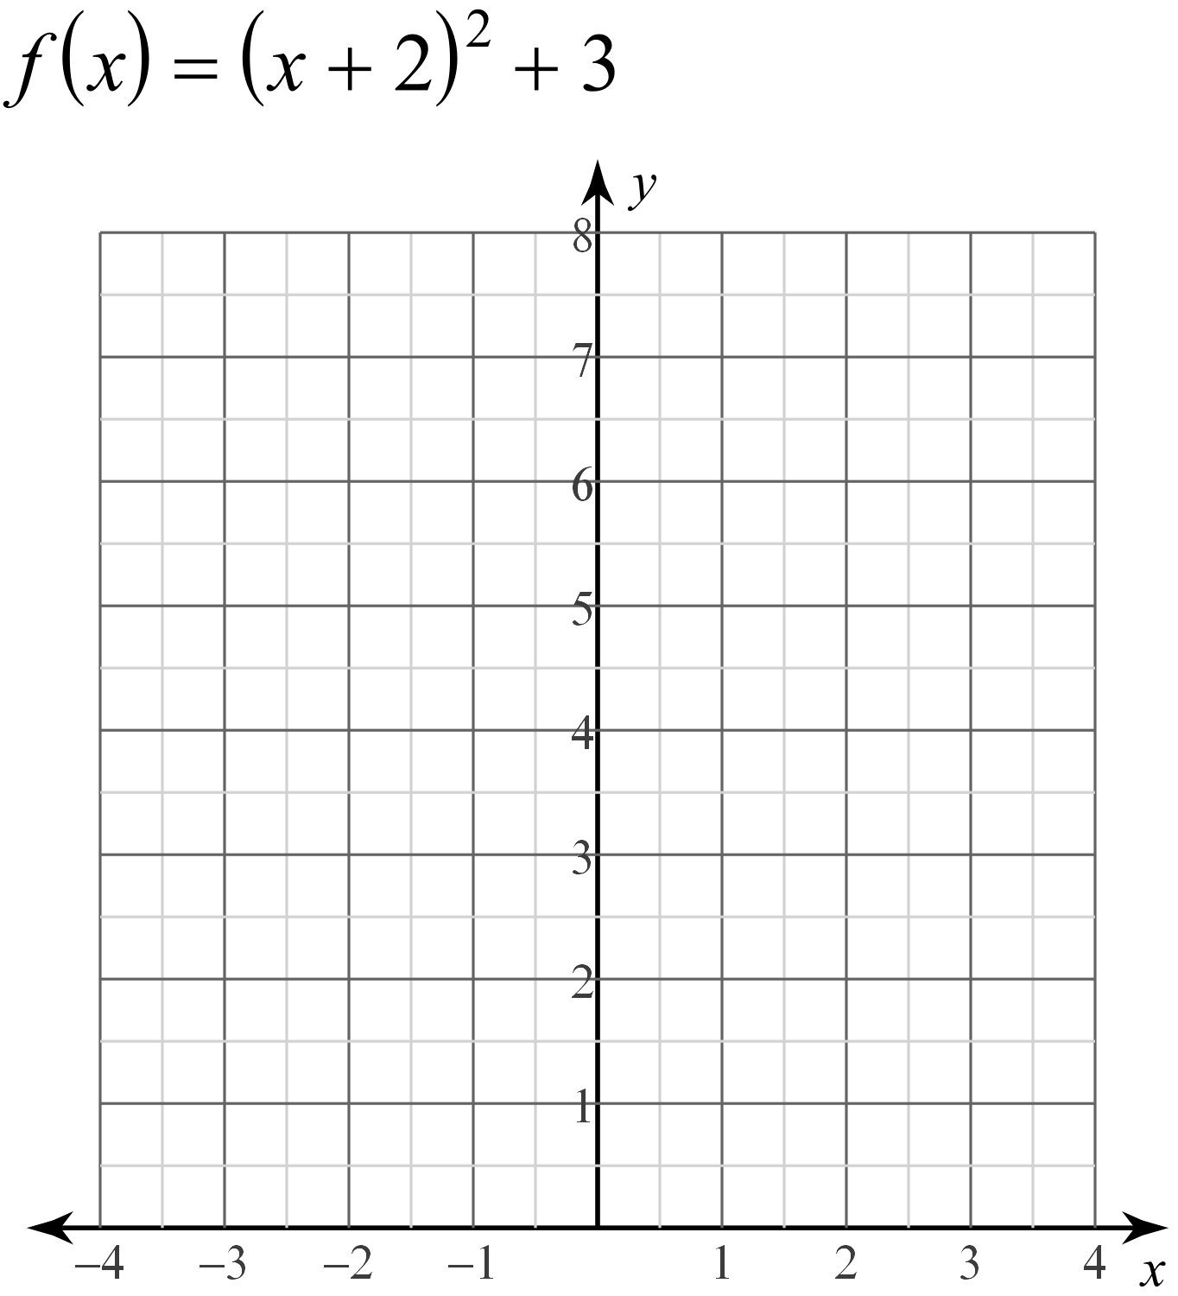
- Rewrite to standard form. Find the axis of symmetry. Find the vertex.
  - $y+3x^{2}=6x-4$
$$y=-3x^{2}+6x-4$$
$$To find axis of symmetry: x=-\frac{b}{2a}$$
$$x=\frac{-6}{2(-3)}$$
$x=1$ axis of symmetry
Plug x = 1 into equation to find y
$$y=-3{\left(1\right)}^{2}+6\left(1\right)-4$$
$$y=-3+6-4$$
$$y=-1$$
Vertex: (1,-1)
  - $y+3x^{2}=6x+4$

- Rewrite vertex form to standard form. (first one is done for you)
  - $y={-2\left(x-3\right)}^{2}+4$
$y={-2\left(x^{2}-6x+9\right)}^{}+4$
$y=-2x^{2}+12x-18+4$
$y=-2x^{2}+12x-14$

  - $y=-4{\left(x+5\right)}^{2}+5$

- Write the equation from the graph
