Module 5 Test Review Name: Period:
Show all your work. Good luck!
1) Rewrite in slope intercept form. Use a table to graph X - 5y = 15  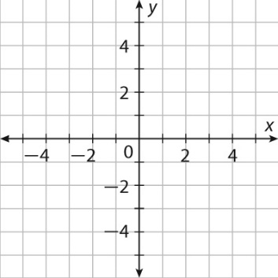 | 2) Rewrite in slope intercept form. Use a table to graph 4x + 2y = 6
3) Graph the function:  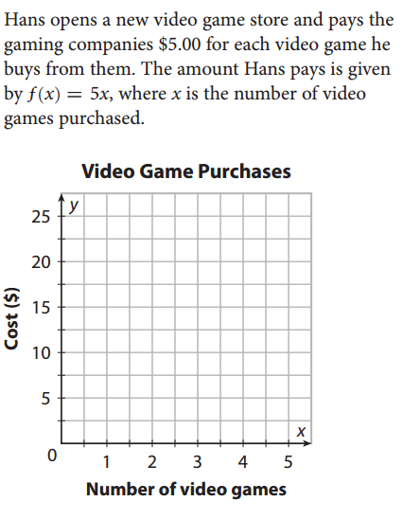  (a)State it’s domain and range:  (b) Is it discrete or continuous? Explain | 4) Does the table represent a linear function? Explain.  X 1 2 3 4 5  y 8 11 14 17 21
 | 5) Find the x and y intercept of 8x – 10y = 44
6) Find the x and y intercepts of
$\frac{2}{3}x-y=-8$
7) Use the slope formula to find the slope of the line that contains the points:
(a) (5,-11) and (-7,15)
(b) (4,-2) and (2,-2)

8) Graph using intercepts: What does each intercept mean?
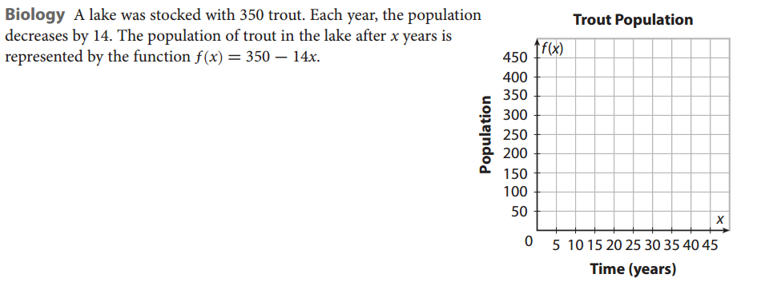
9) Use the table to find the slope of the linear equation.  x 1 3 5 7 9  y -4 0 4 8 12 | 10) The graph below shows the relationship between the number of tortilla chips and total number of calories of the chips.  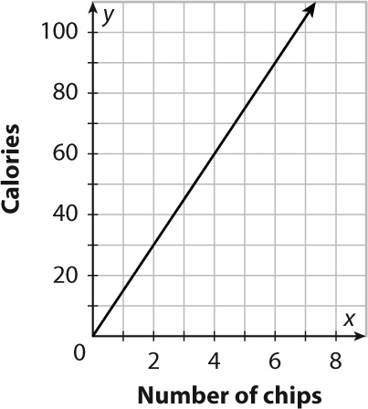  a. Find and interpret the slope.  b. Write an equation to represent the relationship.
11) Solve $2x-3\left(x-2\right)=4+3x-7x$ | 12) Solve $\frac{5}{6}x=-20$
13) Solve $-5\left(x+2\right)>7x$ | 14) solve 10< x + 2< 21

