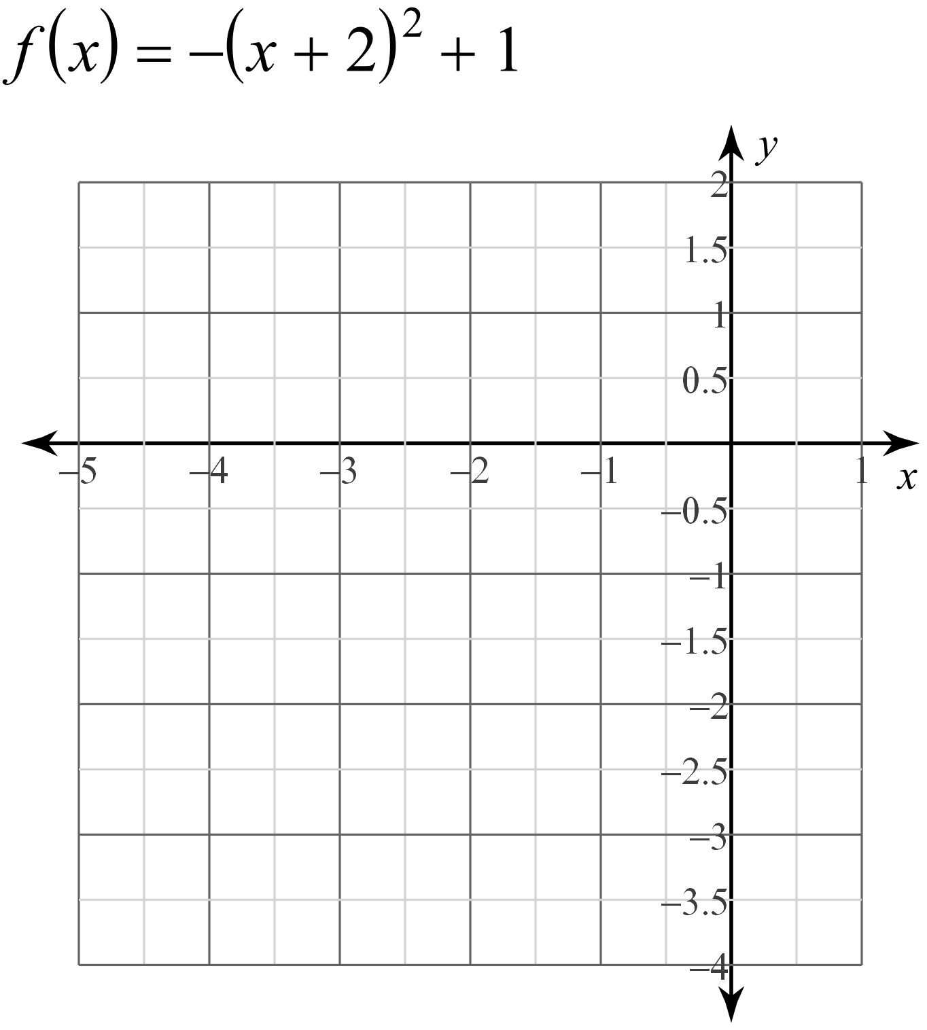  Vertex:__________________  Two points:  X Y  y-intercept:_______________  Domain:_________________  Range:___________________ | 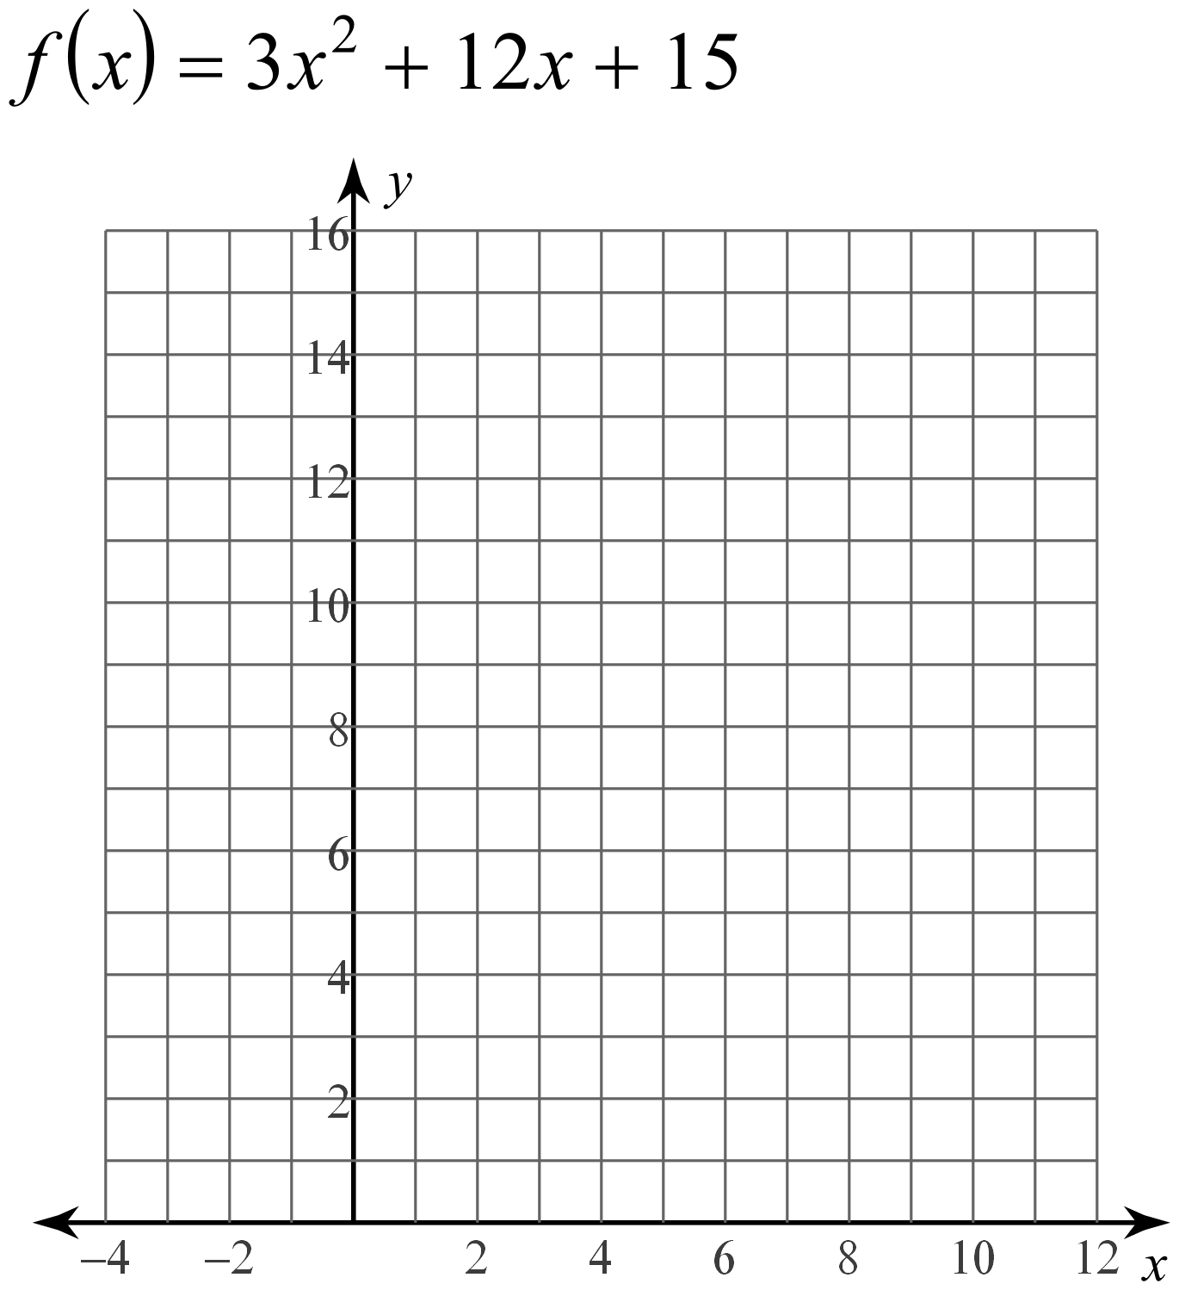  Vertex:__________________  Two points:  X Y  y-intercept:_______________  Domain:_________________  Range:___________________
Warm Up:
- What are the solutions of 3x(x+4) =0?
- Write the function in standard form:
f(x)= -3(x  5) (x – 1)
- The height of a football t seconds after being thrown in the air is modeled by the function
h(t)  5t(3t  10). How long did it take the ball to hit the ground?

Notes: Graphing quadratics in factored form
