Module 10 Test Review

1. Graph . Find the domain and range of State the Transformations:

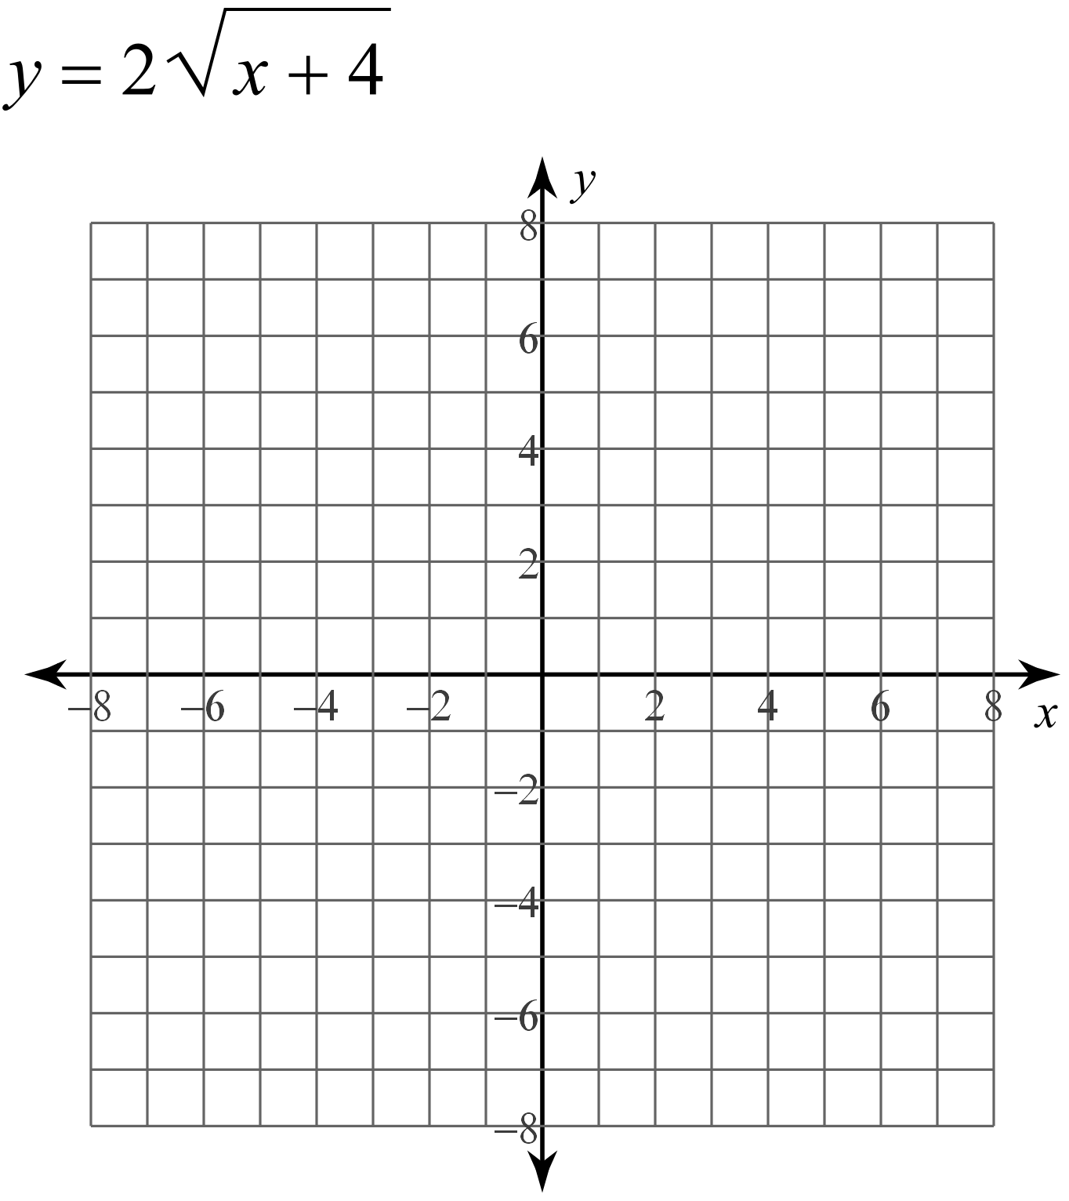

2. Graph . Find the domain and range of State the transformations.



For 3–4, use the function

3. Find the inverse of the function.

4. Graph the function and its inverse.



For 5–7, use the function

5. Find the inverse of the function.

6. Write the compositions to confirm that the two functions are inverses.

7. Graph the function and its inverse.



8. Write the function graphed below in the form ****

