1. Solve the system $\left\{\begin{aligned}x+2y=5 \\ x+6y=9\end{aligned}\right.$.

2. Solve the system $\left\{\begin{aligned}y=5x-1 \\ y=5x+2\end{aligned}\right.$.

3. Solve the inequality

$4\left(n-2\right)-5n≥-3n-10$

4. Is the ordered pair a solution of $\left\{\begin{aligned}y≤2x+5 \\ y<-x\end{aligned}\right.$
A (0, 0) Yes No

5. Graph $y<-\frac{1}{2}x-2$
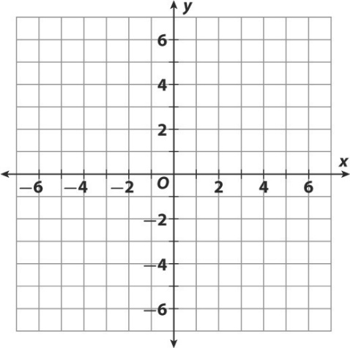

6. Graph$\left\{\begin{aligned}y≥2x-2 \\ y<4x+2\end{aligned}\right.$
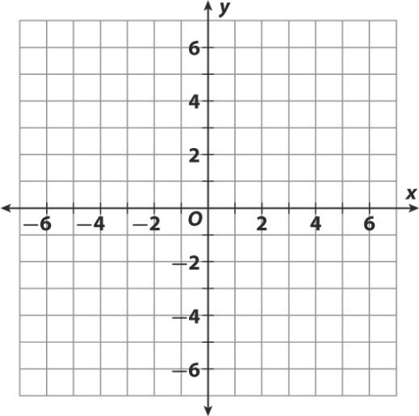
8. Graph $\left\{\begin{aligned}y≥2 \\ 3x-2y<2\end{aligned}\right.$

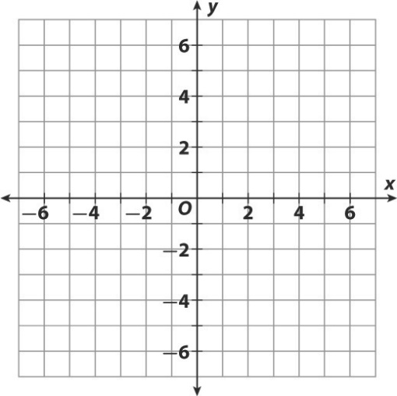

Review word problems found in 12.3/ your homework

