Module 2 Review
module
2

Graph
1. $\left|\frac{3}{4}\left(x-2\right)\right|-3$
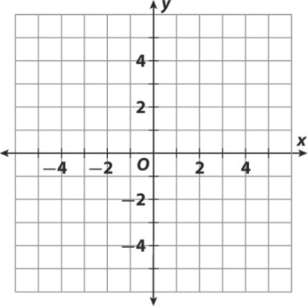

Use the graph below for 2.
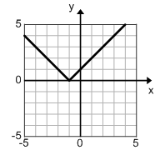
2. Write a function in standard form to match the graph. Let b = 1.

Solve the following equations:
3. Solve $-10\left|x+2\right|=-70$

4. Solve$-3\left|x+2\right|+3=6$

Solve graphically:
5. $\left|x-3\right|+2=5$
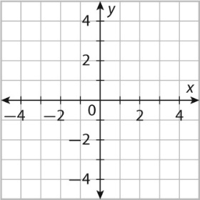
Solve the following inequalities. Graph the solution on a number line.

6. Solve $3\left|-x-4\right|+2>5$?

7. Solve $\left|2x+1\right|-4≤5$

8. Solve $-5\left|2x+5\right|+6<16$

Solve graphically
9. $\left|x-3\right|+2≥-1$
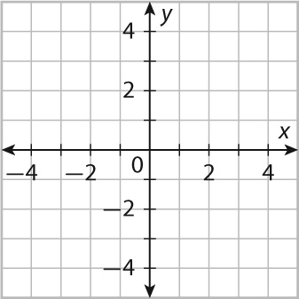

- Know when you get no solution or one solution from absolute value equation.
- Set notations
- Know when you get all real numbers or no solution from absolute value inequality
- Find inverse and graph them

