TRIGONOMETRIC IDENTITIES
Reciprocal identities
$$\tan{x}\cot{x}=1$$
$$\sin{x}\csc{x}=1$$
$$\cos{x}\sec{x}=1$$
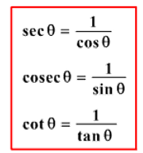
Quotient properties
$$\tan{x}=\frac{\sec{x}}{\csc{x}}$$

$$\cot{x}=\frac{\csc{x}}{\sec{x}}$$

Pythagorean Properties

