Lesson: Writing Sine and Cosine functions from a graph:
Example: Write the sine function of the following graph
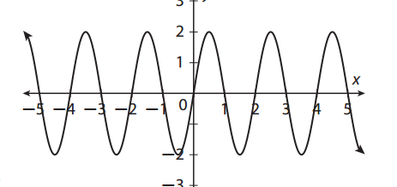
Example: Write the cosine function of the following graph:
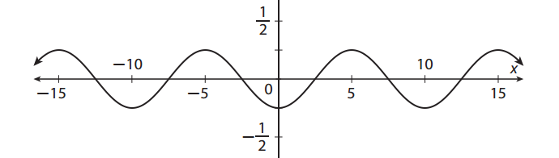
You Try: Write the cosine function of the following graph:
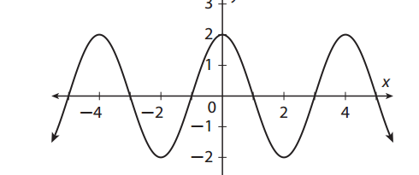
Example: Write the cosine function
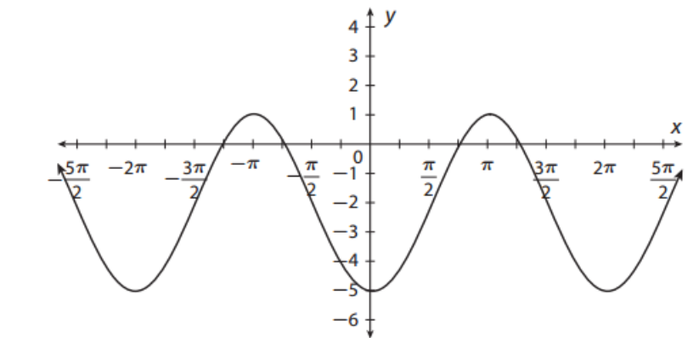
You Try: Write the sine function
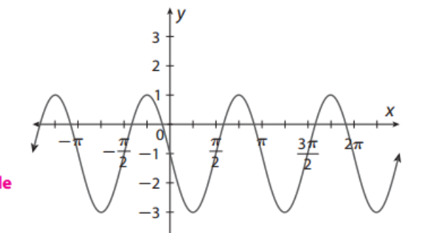

Homework:
1) Write the sine Function 2) Write the cosine function
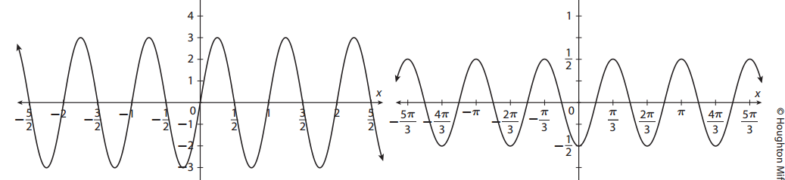
3) write the Sine function 4) write the cosine function

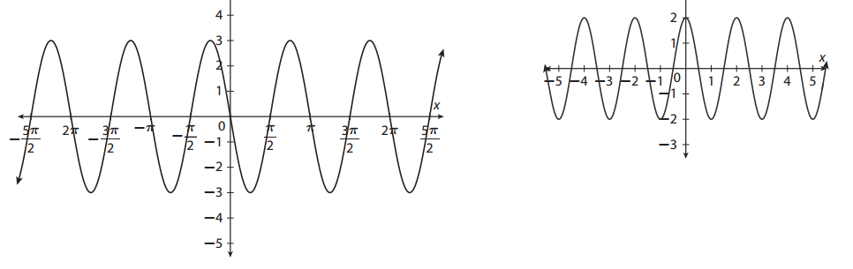
5) Write the Sine function:
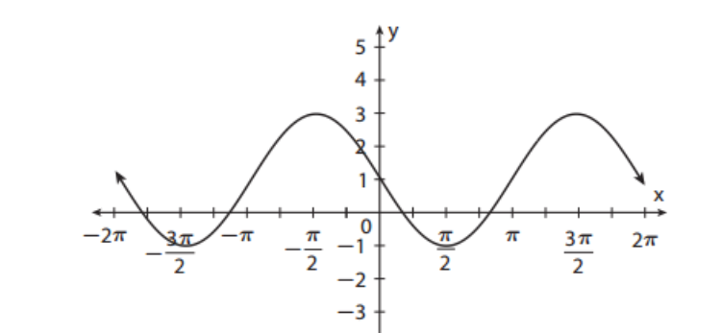
6) Write the cosine function:
